The Best Source of Vitamin D- Sunlight 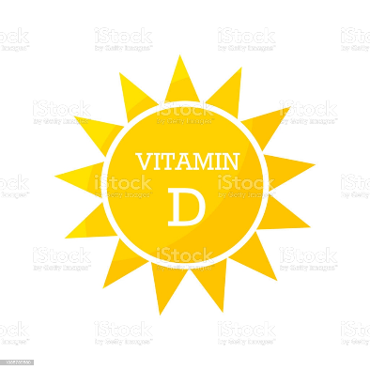

*Very few foods naturally contain Vitamin D -Dermal (skin)synthesis and foods fortified with Vitamin D are the major source.
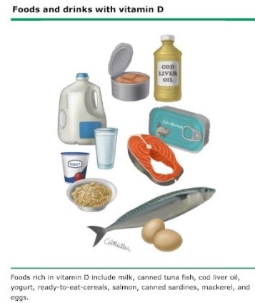

*Benefits of Vitamin D -Vitamin D plays an important role in calcium and bone homeostasis and regulates cellular functions.

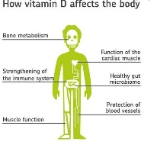
*Risks of Vitamin D deficiency: Deficiency can result from decreased intake, lack of sun exposure, poor absorption or lack of synthesis of active form of Vitamin D in the body. It can cause weak bones, increase risk of fracture, falls.
- Some observational studies show a link between Vitamin D deficiency and respiratory tract infections like colds, bronchitis and pneumonia.
- Another research suggests Vitamin D deficiency can lead to hair loss.

PROS OF SUNLIGHT EXPOSURE:
*Sunlight is a natural and free source of Vitamin D. Sunlight has benefits beyond Vitamin D. For example it stimulates the production of Co Q 10( which facilitates various cellular processes) from chlorophyll byproducts in the green leafy vegetables, hence maximizing the effects of the greens we eat.
*Within 30 min of exposure to sunlight the UV light can cause significant drop in blood pressure through the release of nitric oxide in the system. The prerequisite for this again is to consume greens on a regular basis.
*Morning sun exposure can help with Seasonal Mood disorder.
*Adequate sunlight exposure during the day also stimulates melatonin production at night.

CONS OF SUNLIGHT EXPOSURE:
*Increased risk of cataract- the effect can be minimized by wearing brimmed hat and sunglasses.
*Sunlight also cause aging of skin.
*Excess sunlight - can cause skin cancer -Wearing sunscreen is important.

GOAL: Aim to get 10–30 minutes of midday sunlight without sunscreen, several times per week.
However when one is deficient in Vitamin D, it has to be supplemented through pills.

